First we will start with nmap scan and find the ports are running

We find that port 80 and 443 is open

Now we got to website.

We got through the source page of website but nothing we got important information

For finding the directories present inside the website we are done brute force attack using gobuster tools

After checking some directories we find our first flag in robots directory

I decided to go login directory It show me wordpress login page

We will use burpsuit find the error when we press wrong username and password

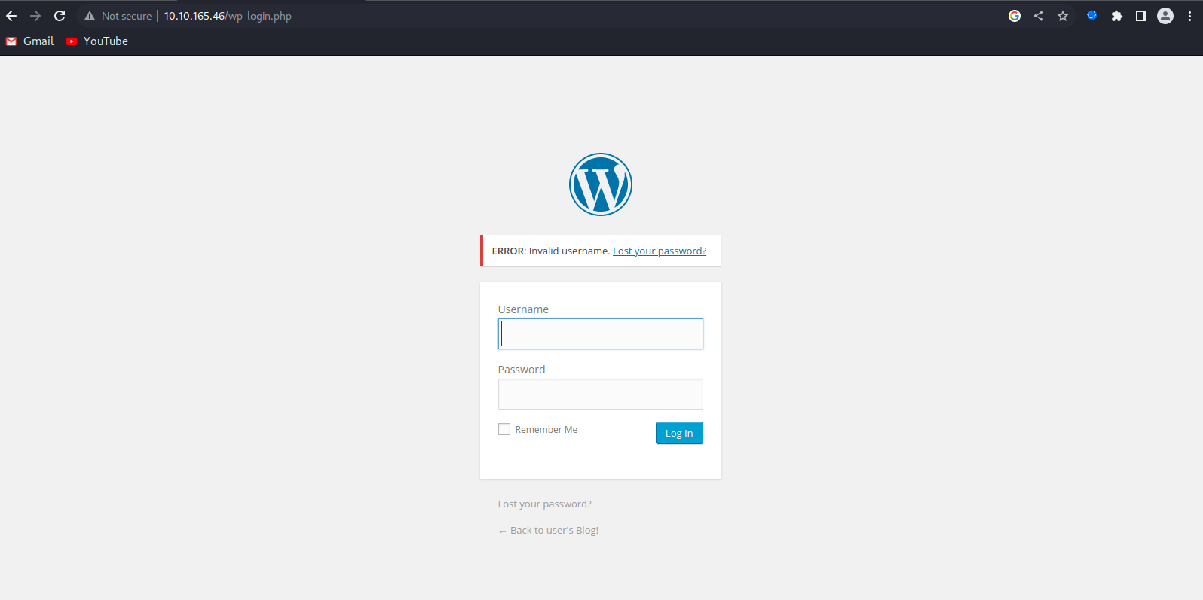

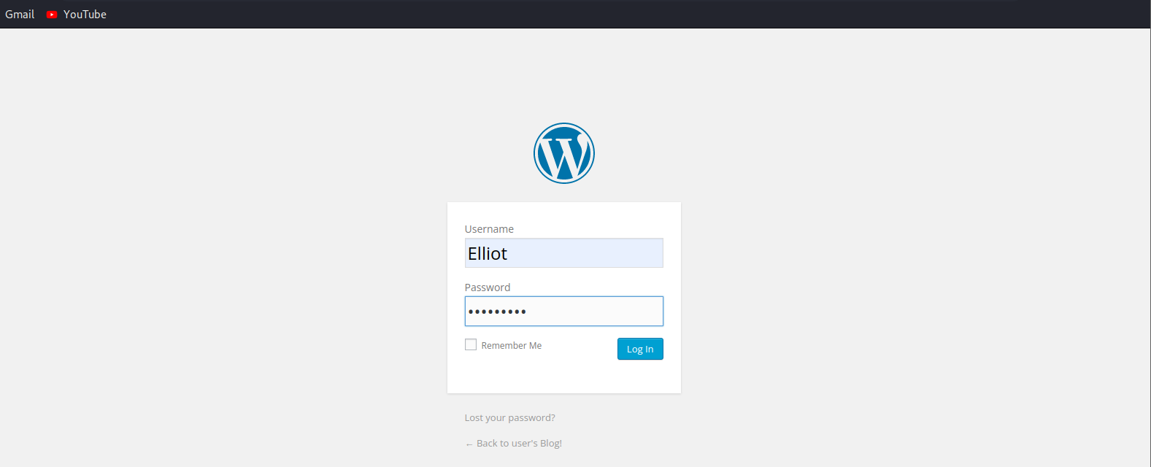

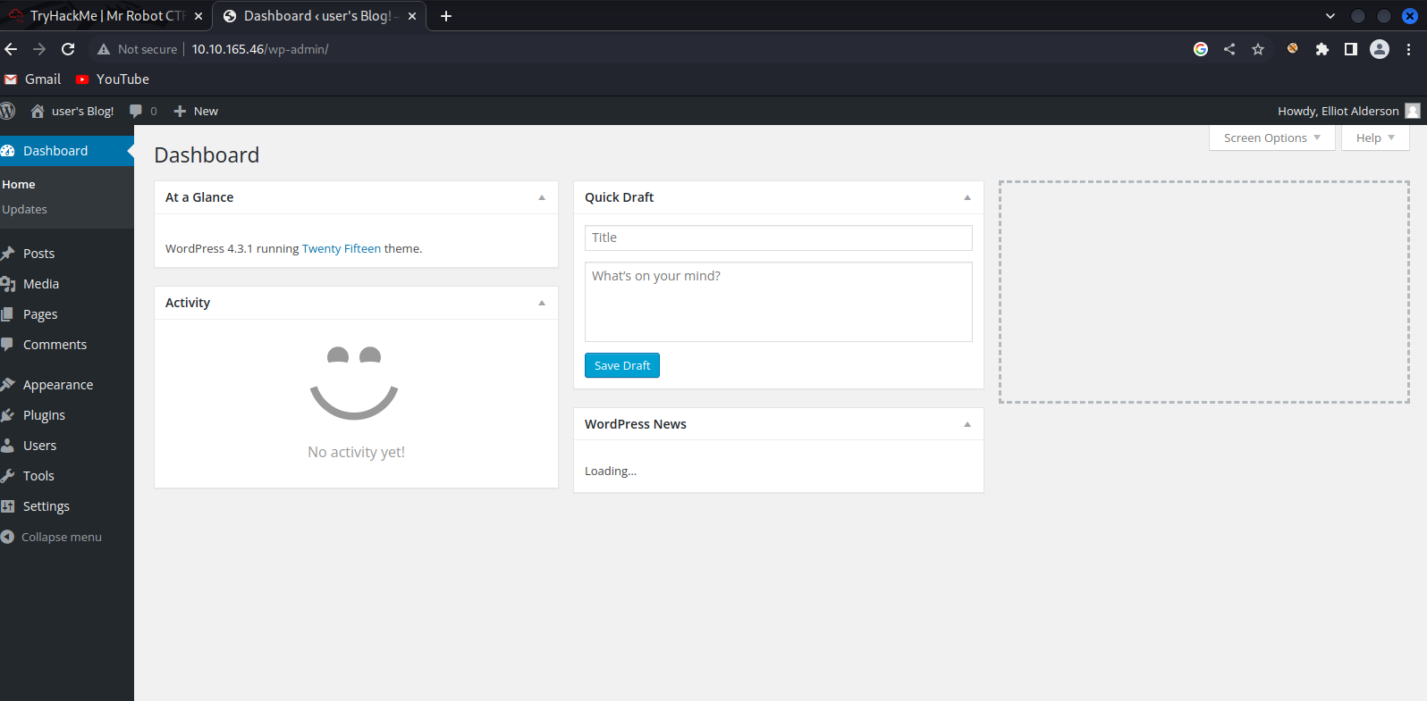

Opening the page http:// 10.10.165.46/wp-includes/themes/TwentyFifteen/404.php

